**HORMISDALLEN SCHOOLS**

**GENERAL KNOWLEDGE FOR BABY CLASS**

**TERM I - III 2020**

**WEEK ONE**

**Orientation**

Identifying, taking interest in and observing people around me.

* Telling their names and teacher’s name
* Naming people at home e.g parents’ names
* Exploring and knowing my immediate environment e.g toilets, dinning, classes, offices, kitchen and plates.
* Naming rooms in the house e.g kitchen, bedroom, sittingroom and bathroom.

**WEEK TWO**

**LESSON I**

* Toilet habits
* Learning how to use the toilet
* Learning how to use the toilet paper
* Learning how to wash hands after using the toilet

**LESSON II**

* Personal hygiene i.e
* Listening and telling stories about personal hygiene.
* Describing steps taken to ensure personal hygiene.
* Reciting rhymes about personal.
* Practicing personal hygiene and dramatization.

**LESSON II**

* Eating habits
* Practicing to wash hands before and after eating food.
* Thanking God for the food.
* Practicing to use of hands while eating.

**LESSON III**

* Eating habits
* Singing songs about eating habits
* Mentioning good eating habits

**WEEK THREE**

**LESSON I**

* Care for the utensils
* Preparing materials to use

**LESSON II**

* Washing and drying utensils
* Arranging utensils in the plate stand

**WEEK FOUR**

**LESSON I**

* Our environment
* Learning how to keep our environment clean by:-
* Sweeping, picking rubbish, mopping.
* Telling news about things in the environment e.g what they see on their way to school.

**LESSON II**

* Drawing and naming objects found in their environment
* Singing songs, reciting rhymes about the environment
* Learning compositions about the environment

**WEEK FIVE**

**LESSON I**

* Important people at school e.g
* Director
* Headteacher
* Teacher
* Mentioning important people I the school
* Responsibilities of important people at school
* Role playing or roles done by important people at school e,g

Teacher, teaches the pupils

**LESSON II**

* Important people at school i.e
* Bursar, Secretary, Cooks, Cleaners
* Mentioning important people and their responsibilities
* Role playing activities done by the people mentioned above.

**WEEK SIX**

**LESSON I**

* God’s creation
* Talking about God’s creation
* Listening to stories about God’s creation
* Reciting rhymes about God’s creation

**LESSON II**

* God’s creation i.e
* Mentioning things made by God and man made things
* Drawing and shading pictures of God’s creation

**WEEK SEVEN**

**LESSON I**

* Common etiquettes i.e
* Greeting
* Appreciation
* Acting upon the given etiquettes accordingl

**LESSON II**

* Continuation of common etiquettes
* Requesting
* Apologizing
* Learning how to request in a good manner
* Learning how to apologisee.g saying sorry

**WEEK EIGHT**

**LESSON I**

* Easter festival i.e
* Telling what happens on Easter day
* Answering oral questions about Easter
* Telling stories about Easter day

**LESSON II**

* Continuation of Easter festival
* Drawing and shading the Easter party e.g the Christmas tree, cake

**TERM II - 2020**

**CONTENT:**

**Week I: Period I:**

Shade the dangerous objects.

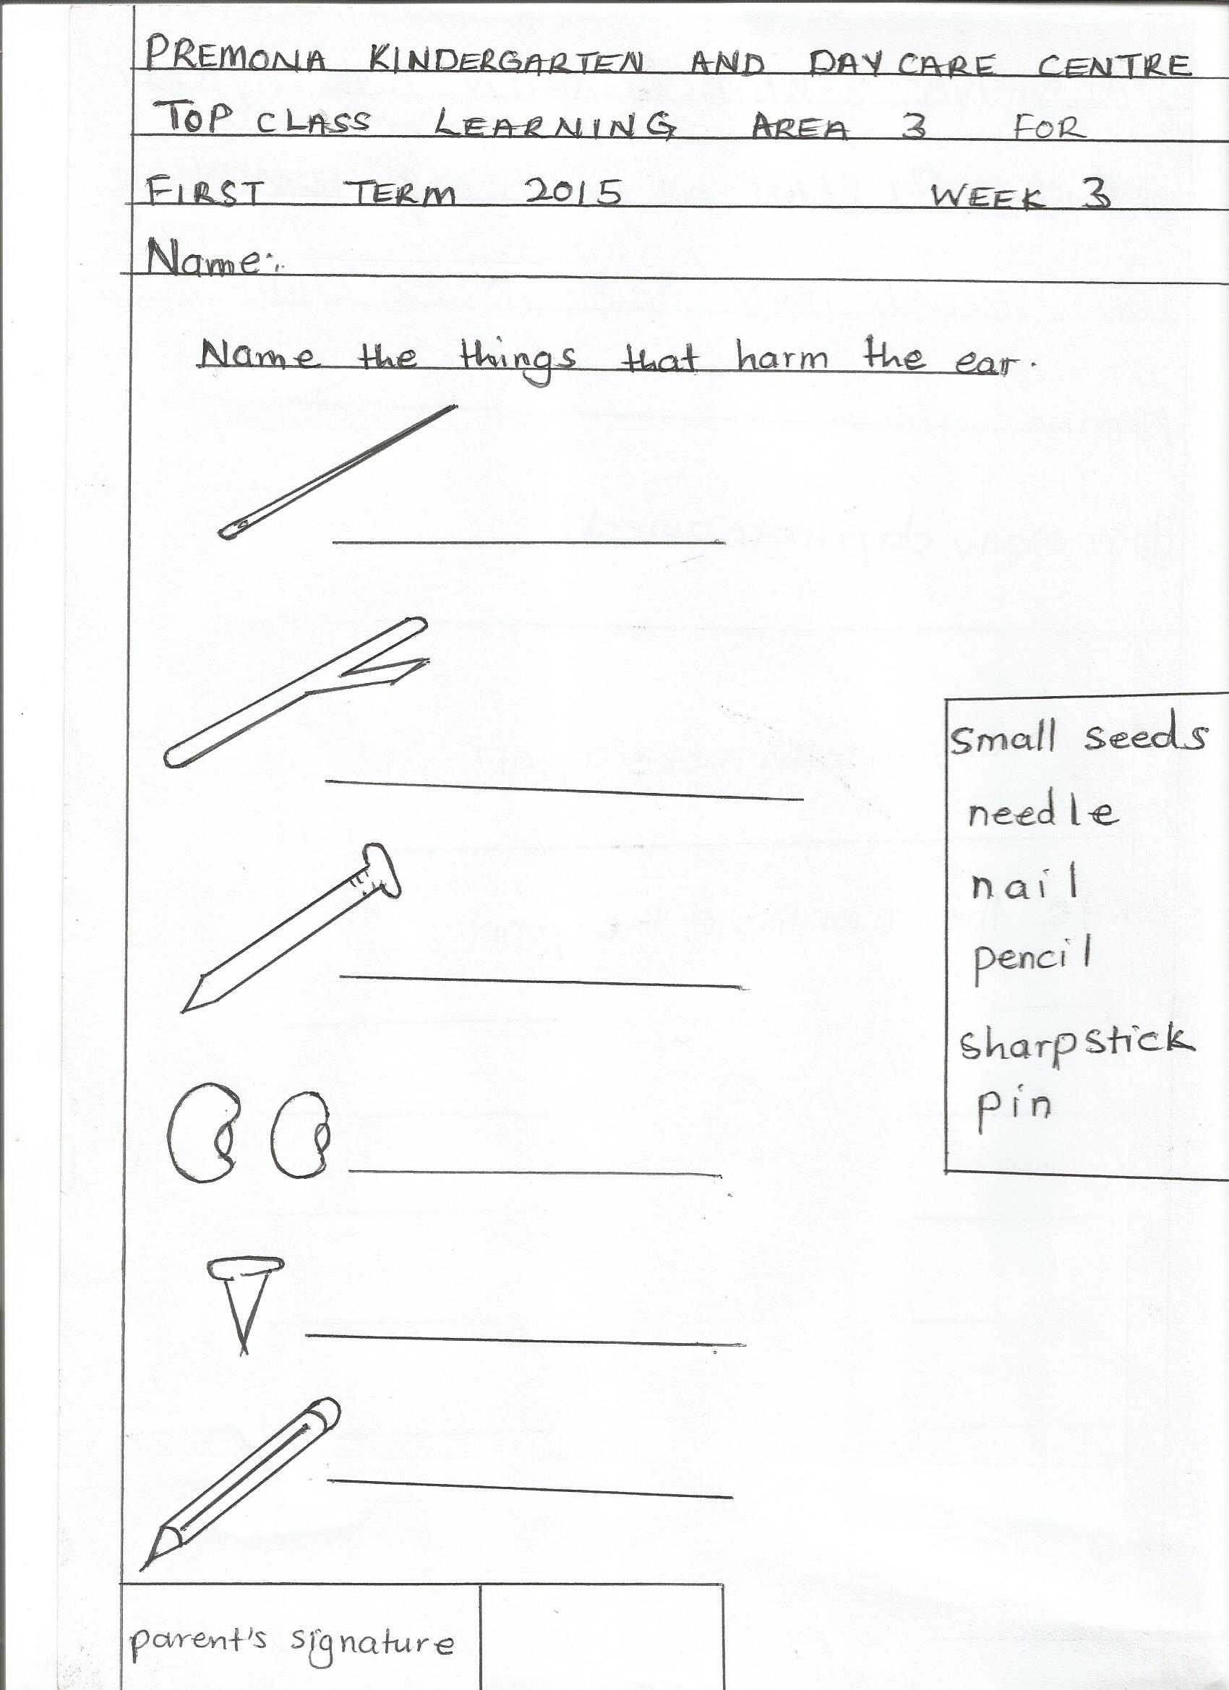



**ACTIVITIES**:

* Shading
* Reciting rhymes
* Telling news

**Period 2: Content:**

**Match the same**

**Activities:**

* Matching
* Identifying
* Recognizing

**Week 2: Period 1: Content:**

Shade the things we use to clean our body.

|  |  |  |  |
| --- | --- | --- | --- |
|  | Related imagehttps://encrypted-tbn3.gstatic.com/images?q=tbn:ANd9GcRl2-VOiX4xpWskqUoo0-1dSqhYakiC-ZBCdWIQcMAnI8uRnp8Z |  | Related image |

**Activities:**

* Shading
* Recognizing
* Rhyming
* Identifying

**Period2: Content:**

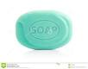**Match the same Activities:**

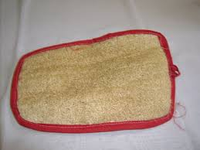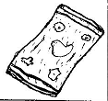matching

identifying

reciting rhymes

**Week 3: Period 1: Content:**

Shade the body parts.

|  |  |  |
| --- | --- | --- |
| Related image  Related image | Related image | Related image |
|  | Related image | Related image |

**Activities:**

* Shading
* Naming orally
* Recognizing

**Period 2: Content;**

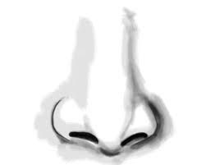Match the same. Activities:

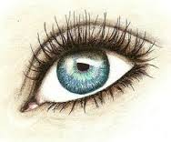Matching

Identifying

Reciting

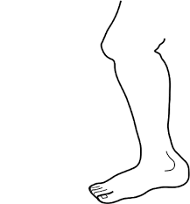naming orally





**Week 3: Period 1: content:**

**Tell the senses. (orally)**



eyes for seeing.

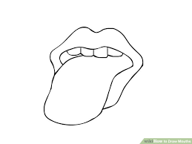

tongue for tasting



Nose for smelling

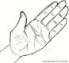

Fingers for feeling.



Leg for jumping, walking and matching.

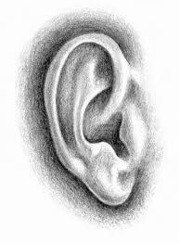

ear for hearing.

 Mouth for eating

**Activities:**

* Rhyming
* Reciting
* Listening
* Imitating

**Week 4: Period 1: Content:**

Shade the family members.

|  |  |  |  |
| --- | --- | --- | --- |
| Related image  Related image | Related image | http://artbyrichardmoore.homestead.com/files/22_boy.jpg | Related image |
|  | Related image | Related image |  |

**Activities:**

* Shading
* recognizing
* reciting
* identifying

**Period 2: Content**

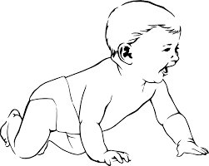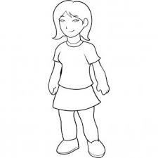**Match the same. Activities**

* Matching
* Observation
* 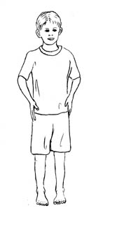reciting



**Week 5 Period 1: Content:**

Shade the things we wear.

|  |  |  |  |
| --- | --- | --- | --- |
| Related image | Related image | Related image | Related image |

Activities:

* Shading
* Identifying
* Reciting

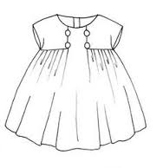**Period 2: Content**: Match the belonging



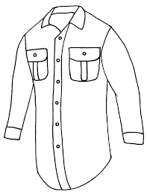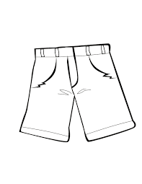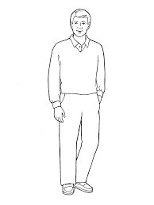

**Activities**:

* Matching
* Recognizing
* Reciting
* Naming

**Week 6: Content:**

**Period 1:** Shade and draw fruits.

|  |  |  |  |
| --- | --- | --- | --- |
| Related image | Related image | Related image | Related image |
|  |  |  |  |

**Period 2:**

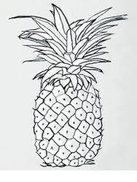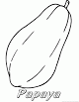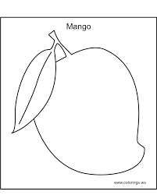

**Activities:**

Naming shading, drawing and recognizing

**Week 7: Content: Period 1**

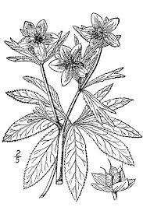Shade green plants.

**Activities**

Shading

Naming

Identifying

**Content:**

**Period2 : Draw the plants.**

**Activity:**

* Drawing
* Demonstrating
* Recognizing

**Content: Period 1 Week 8**

Shade the food.

|  |  |  |  |  |
| --- | --- | --- | --- | --- |
| Related image | Related image | Related image | Related image | Related image |

**Activities:**

Shading, Identifying, Naming

**Week 8: Content:**

**Period 2: Match the food.**

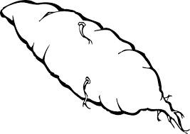

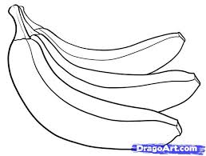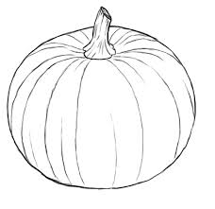

Activities:

* Matching
* Naming
* Identifying.

TERM III

Lesson notes for general knowledge

Week I

Period I

Content: Toilet habits

Activities

* Talking about the good use of the toilet
* Talking about the good use of the toilet paper
* Soap and water
* Talking about washing hands after using toilet

Period 2

Content: Personal hygiene

Activities

* Describing the steps taken to ensure personal hygiene
* Talking about good personal hygiene
* Talking about bad ways of personal hygiene
* Telling and reciting rhymes about personal hygiene
* Practicing and dramatizing good personal hygiene.

Week 2

Period 1

Content: Eating habits

Activities:

* Practicing to wash hands before and after eating.
* Thanking God for the gift of food (praying)
* Talking about food that may harm our health e.g. too much meat, sweets fats etc.
* Practicing eating while covering mouth.

Period 2

Content: eating habits

Activities.

* Talking about important foods
* Talking about less important foods
* Brushing tooth after eating
* Dramatising good eating habits
* Dramatising bad eating habits
* Talking about good table manner.

Week 3

Period 1

Content: Care for the utensils

Activities:

* Washing and drying utensils.
* Keeping utensils in the right place.
* Covering utensils where it is kept.
* Arranging the utensils accordingly.

Period 2

Content: Care for the utensils.

* Proper use of utensils.
* Using the utensils in a right place
* Cleaning utensils after use.

Week 4

Period 1

Content: Our environment.

* My immediate environment, things found e.g. plants, animals, birds, manmade structures and their uses.
* Taking care for the flowers in the environment.
* Management of litter in our environment
* Practicing in making the environment clean and safe.

Period 2

Content: Our environment.

Activities:

* Talking about dangerous objects in our environment.
* Talking about some domestic animals can be dangerous,
* Talking about wrong and right people in our environment.
* Drawing and naming pictures found in our environment.

Week 5

Period 1

Content: Leaders in the community

Activities:

* Mentioning the leaders in our wider community e.g.
* political leaders
* religious leaders
* cultural leaders

Period 2

Content: Leaders in the community.

Activities:

* Mentioning where these leaders are found.
* Role they play.
* Talking about their responsibilities for our well-being in the community.

Week 6

Period 1

Content: Story of creation / spiritual life. (God’s creation)

Activities:

* Talking about God’s creation e.g. man, animals, birds, plants, lakes, rivers, mountain, forests etc.
* Telling and listening to stories about God’s creation.
* Reciting rhymes and singing songs about God’s creation.

Period 2

Content: God’s creation.

Activities:

* Mentioning things made by God
* Thanking God for his creation
* Drawing and shading things made by God.
* Moving around to see God made things around us e.g. plants, animals, man etc.

Week 7

Period 1-2

Content: Common etiquettes

Activities:

* Use of polite language e.g. greeting, apologizing, appreciating, requesting.
* Being helpful to others.
* Saying sorry to those that you have hurted and forgiving one another.

Week 8

Period 1-2 content: Christmas festival

Activities:

* Explaining what Christmas is all about.
* Talking about what happens on Christmas day.
* Answering oral questions about Christmas.
* Telling stories about Christmas day.
* Drawing and shading the Christmas party tree, Christmas cake, father Christmas.
* Dramatizing.